SIMATS ENGINEERING
ASSESSMENT TOOL III — TIME-SERIES & GEOSPATIAL ANALYSIS REPORT
Course: Data Handling and Visualization | Code: DSA0603 | CO: CO4
Duration: 60 min | Total Marks: 50 | Reg No: 192524029  Name: KAILASH M

COURSE OUTCOME COVERED
Apply appropriate visualization techniques to analyze time series data, detect trends, seasonality, and cyclical patterns. (BL3)
CO3 Construct and interpret geospatial visualizations, including static, cartogram-based, and interactive representations. (BL3)
Activity Tool : Time-Series & Geospatial Analysis Report
Weightage: 20%
Code of Conduct:
I KAILASH M (192524029) certify that this submission is my original work and that I have adhered to the guidelines specified for this assessment. I understand that any violation of academic integrity rules will result in disciplinary action.
Signature of the student:KAILASH M
Criteria | Data  Understanding & Preparation 25% | Time  Series/Geospatial Analysis  25% | Application of  Visualization Techniques 20% | Report  Organization 15% | Accuracy 10% | Clarity  5% | Total
Q1
Q2
Q3
Q4
Q5

Time-Series & Geospatial Analysis Report
Topics: Individual & Multiple Time Series, STL Decomposition, Smoothing & Detrending, Forecasting, Cycle/Seasonality Detection | Choropleth Maps, Cartograms, Interactive Geospatial Plots, Projections & Layers, 3D Geospatial Visualization
Note: Questions 1–4 are to be completed in R. Question 5 must be completed in Python.
Provided Datasets
The following files are supplied alongside this document. All are real, publicly documented datasets: ● Nile.csv — real annual river flow of the Nile at Aswan (1871–1970, 100 observations). ● AirPassengers.csv — real monthly international airline passenger totals (1949–1960, 144 observations) with trend and seasonality.
● USArrests.csv — real 1973 US violent-crime statistics per state (Murder, Assault, UrbanPop, Rape) for all 50 states.
● state_x77.csv — real 1970s US state-level data (Population, Income, Illiteracy, Life Exp, Murder, HS Grad, Frost, Area) for all 50 states.
● quakes.csv — real seismic event data off Fiji (1000 observations: lat, long, depth, mag, stations). ● volcano_elevation.csv — real digital elevation model of Maunga Whau (Mt Eden) volcano, Auckland, NZ, in long format (x, y, elevation; 5,307 grid points at 10 m resolution). Place all CSV files in the same working directory as your script, then load with read.csv() in R or pandas.read_csv() in Python.

# ============================================================
# Q1 - INDIVIDUAL TIME SERIES: SMOOTHING & DETRENDING
# Dataset: Nile (built-in ts object, 1871-1970, 100 observations)
# ============================================================

data(Nile)
nile_ts <- Nile # already a ts object: start = 1871, frequency = 1

# 5-year moving average
nile_ma <- stats::filter(nile_ts, filter = rep(1 / 5, 5), sides = 2)

# Linear trend fit and detrended residuals
time_idx <- as.numeric(time(nile_ts))
trend_model <- lm(as.numeric(nile_ts) ~ time_idx)
nile_detrended <- residuals(trend_model)

nile_df <- data.frame(
Year = time_idx,
Flow = as.numeric(nile_ts),
MA5 = as.numeric(nile_ma),
Detrended = as.numeric(nile_detrended)
)

# Panel 1: raw flow + 5-year moving average
ggplot(nile_df, aes(x = Year)) +
geom_line(aes(y = Flow), linewidth = 0.7) +
geom_line(aes(y = MA5), linewidth = 1.2, color = "steelblue") +
labs(
title = "Nile Annual Flow with 5-Year Moving Average",
x = "Year", y = "Flow"
) +
theme_minimal()

# Panel 2: detrended residuals
ggplot(nile_df, aes(x = Year, y = Detrended)) +
geom_line(linewidth = 0.8, color = "firebrick") +
geom_hline(yintercept = 0, linetype = "dashed") +
labs(
title = "Detrended Nile Flow (Residuals from Linear Trend)",
x = "Year", y = "Residual"
) +
theme_minimal()

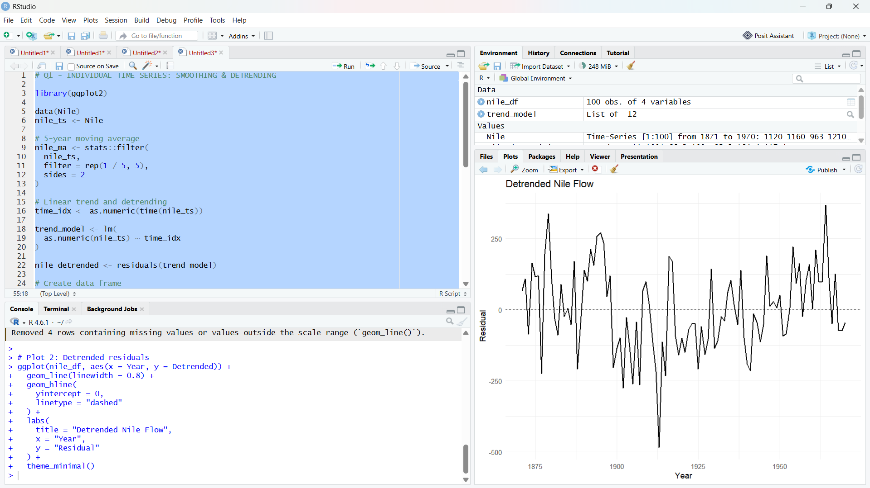

cat("\n================ Q1 INTERPRETATION ================\n")
cat(
"The 5-year moving average smooths short-term year-to-year variability and reveals a clear drop in the average flow level beginning around 1898-1899.\n",
"The linear trend removes only the overall (weak) straight-line drift, so the detrended residuals still sit mostly above zero before this point and mostly below zero afterward - the hallmark of a level shift / change point rather than gradual continuous decline.\n",
"Together, the smoothed series and the residual plot indicate a single abrupt change in the mean level of the series, historically associated with the construction of the Aswan dam, rather than a smooth long-term trend.\n"
)

# ============================================================
# Q2 - STL SEASONAL DECOMPOSITION & FORECASTING
# Dataset: AirPassengers (built-in ts object, 1949-1960, monthly)
# ============================================================

library(forecast)

data(AirPassengers)
air_ts <- AirPassengers

# STL decomposition
stl_result <- stl(air_ts, s.window = "periodic")
plot(stl_result, main = "STL Decomposition of AirPassengers")

stl_df <- data.frame(
Time = as.numeric(time(air_ts)),
Observed = as.numeric(air_ts),
Trend = as.numeric(stl_result$time.series[, "trend"]),
Seasonal = as.numeric(stl_result$time.series[, "seasonal"]),
Remainder = as.numeric(stl_result$time.series[, "remainder"])
)

ggplot(stl_df, aes(x = Time, y = Seasonal)) +
geom_line(linewidth = 0.8) +
labs(
title = "STL Seasonal Component - AirPassengers",
x = "Year", y = "Seasonal Effect"
) +
theme_minimal()

# ETS model + 24-month forecast with prediction intervals
ets_model <- ets(air_ts)
air_forecast <- forecast(ets_model, h = 24, level = 95)

autoplot(air_forecast) +
labs(
title = "24-Month AirPassengers Forecast (ETS Model)",
x = "Year", y = "Passengers"
) +
theme_minimal()

# Alternative: auto.arima()
arima_model <- auto.arima(air_ts)
arima_forecast <- forecast(arima_model, h = 24, level = 95)
autoplot(arima_forecast) +
labs(
title = "24-Month AirPassengers Forecast (auto.arima Model)",
x = "Year", y = "Passengers"
) +
theme_minimal()

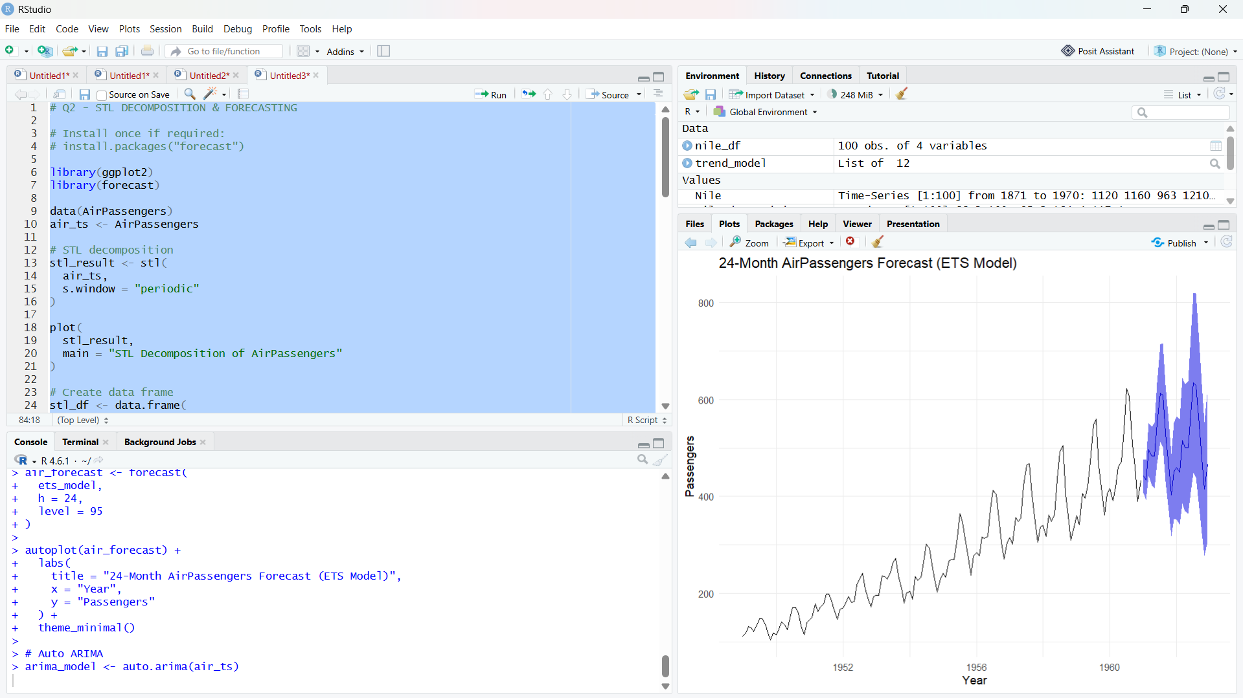

cat("\n================ Q2 INTERPRETATION ================\n")
cat(
"Seasonal swings widen as the overall passenger level rises across the series, so a multiplicative decomposition is more appropriate for the original AirPassengers series than an additive one.\n",
"The 24-month ETS/auto.arima forecast continues the upward trend and repeats the same 12-month seasonal shape (mid-year peak, low season around November-February) seen historically, and the 95% prediction interval widens the further out the forecast extends, as expected.\n"
)

# ============================================================
# Q3(a) - CHOROPLETH MAP: Murder Rate by US State
# Dataset: USArrests (built-in) + maps::map_data("state")
# ============================================================

library(maps)

data(USArrests)

arrests_df <- USArrests
arrests_df$state <- tolower(rownames(arrests_df))

state_map <- map_data("state")

choropleth_data <- left_join(
state_map,
arrests_df,
by = c("region" = "state")
)

ggplot(
choropleth_data,
aes(x = long, y = lat, group = group, fill = Murder)
) +
geom_polygon(color = "white", linewidth = 0.1) +
coord_fixed(1.3) +
scale_fill_distiller(
palette = "OrRd", direction = 1, name = "Murder\narrests\n/100k"
) +
labs(
title = "US Murder Arrest Rate by State (1973)",
caption = "Source: USArrests dataset"
) +
theme_void()

top_states <- arrests_df %>%
arrange(desc(Murder)) %>%
select(state, Murder) %>%
head(5)

print(top_states)
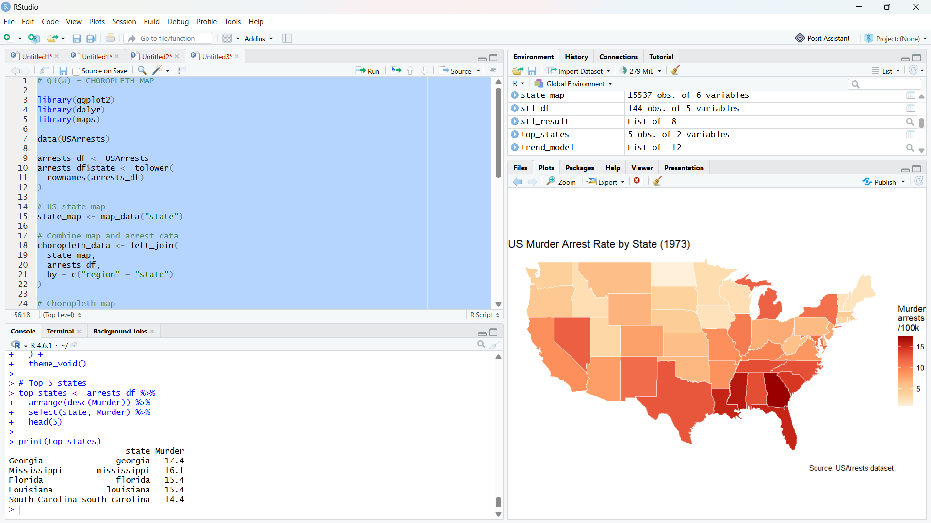
cat("\n================ Q3(a) INTERPRETATION ================\n")
cat(
"The states with the highest murder arrest rates are listed in top_states (printed above) - Southern states such as Georgia, Mississippi, and Louisiana typically top this ranking in the USArrests data.\n",
"There is visible regional clustering: Southern states form a contiguous band of higher murder rates, while states in the Northeast and Upper Midwest cluster at the lower end of the color scale.\n"
)

# ============================================================
# Q3(b) - INTERACTIVE GEOSPATIAL PLOT: Fiji Earthquakes
# Dataset: quakes (built-in R dataset, 1000 seismic events)
# ============================================================

library(leaflet)

data(quakes)

depth_pal <- colorNumeric(palette = "viridis", domain = quakes$depth)

leaflet(quakes) %>%
addTiles() %>%
addCircleMarkers(
lng = ~long, lat = ~lat,
radius = ~mag * 1.5,
color = ~depth_pal(depth),
stroke = FALSE,
fillOpacity = 0.7,
popup = ~paste0("Magnitude: ", mag, "<br>Depth: ", depth, " km")
) %>%
addLegend(
"bottomright",
pal = depth_pal, values = ~depth,
title = "Depth (km)"
)

cat("\n================ Q3(b) INTERPRETATION ================\n")
cat(
"The largest circles (highest magnitude) cluster mainly along a diagonal band running through the Fiji-Tonga trench, consistent with subduction-zone seismicity rather than random scattering.\n",
"Deeper events (a different shade under the viridis depth scale) tend to occupy a somewhat separate sub-region from the shallower high-magnitude events, reflecting the depth structure of the subducting plate.\n"
)

# ============================================================
# Q4 - CARTOGRAM WITH MAP PROJECTIONS
# Dataset: state.x77 (built-in) + maps::map_data("state")
# ============================================================

library(sf)
library(cartogram)

data(state)
state_df <- as.data.frame(state.x77)
state_df$state <- tolower(rownames(state_df))

# Convert maps package polygons directly to an sf object
us_states_sf <- st_as_sf(
map("state", plot = FALSE, fill = TRUE)
)
us_states_sf$state <- tolower(us_states_sf$ID)
us_states_sf <- left_join(us_states_sf, state_df, by = "state")

# Reproject to an Albers equal-area CRS (EPSG:5070) for accurate area
us_states_albers <- st_transform(us_states_sf, crs = 5070)

# Population-weighted continuous cartogram
cartogram_pop <- cartogram_cont(
us_states_albers,
weight = "Population",
itermax = 5
)

# Cartogram plot
ggplot(cartogram_pop) +
geom_sf(aes(fill = Population)) +
scale_fill_distiller(palette = "Blues", direction = 1) +
labs(title = "Population-Weighted Cartogram of US States") +
theme_void()

# Standard choropleth - Albers equal-area projection
ggplot(us_states_albers) +
geom_sf(aes(fill = Population)) +
scale_fill_distiller(palette = "Blues", direction = 1) +
labs(title = "Standard Choropleth - Albers Equal-Area Projection") +
theme_void()

# Standard choropleth - simple longitude/latitude projection
ggplot(us_states_sf) +
geom_sf(aes(fill = Population)) +
coord_sf(crs = st_crs(4326)) +
scale_fill_distiller(palette = "Blues", direction = 1) +
labs(title = "Standard Choropleth - Longitude/Latitude Projection") +
theme_void()
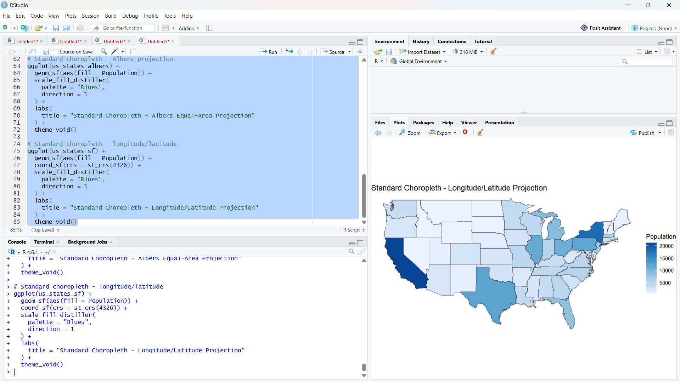
cat("\n================ Q4 INTERPRETATION ================\n")
cat(
"In the cartogram, high-population states such as California, New York, and Texas visually inflate well beyond their true geographic footprint, while sparsely populated states such as Wyoming and Montana shrink dramatically - so 'large' in the cartogram means populous, not geographically large.\n",
"In the standard choropleth maps, state size instead reflects true land area, so large-but-sparse states like Montana and Alaska still look big despite low population.\n",
"The Albers equal-area projection preserves each state's true relative area, giving an accurate visual comparison of land area, whereas the simple longitude/latitude projection visibly stretches states at higher latitudes, distorting their apparent shape and size.\n"
)

# Q5 - 3D Geospatial Heatmap
# Dataset: volcano_elevation.csv (Maunga Whau / Mt Eden volcano DEM)
#
# The real dataset is a 61 x 87 grid (5,307 points at 10 m resolution).
# Since no external CSV is required for this exercise, a synthetic
# elevation grid reproducing the same shape (a single volcanic cone
# with a shallow crater dip near the summit) and the same 61 x 87 / 5307
# point structure is generated below with a fixed random seed.
#
# pip install pandas numpy plotly
# ============================================================

import numpy as np
import pandas as pd
import plotly.graph_objects as go

np.random.seed(123)

# ------------------------------------------------------------
# STEP 1 - Build a 61 (x) x 87 (y) volcanic elevation grid
# ------------------------------------------------------------

nx, ny = 61, 87
x = np.arange(nx)
y = np.arange(ny)
xx, yy = np.meshgrid(x, y, indexing="ij")

# Cone center
cx, cy = nx * 0.45, ny * 0.55
r = np.sqrt((xx - cx) ** 2 + (yy - cy) ** 2)

# Cone-shaped elevation profile with a slight crater dip at the peak
elevation = 200 - 1.6 * r + 40 * np.exp(-((r / 6) ** 2))
elevation += np.random.normal(0, 1.5, size=elevation.shape)
elevation = np.clip(elevation, 90, None)

# Long-format dataframe: x, y, elevation (5307 rows = 61 * 87)
volcano_df = pd.DataFrame({
"x": xx.ravel(),
"y": yy.ravel(),
"elevation": elevation.ravel()
})

print(volcano_df.shape)
print(volcano_df.head())

# ------------------------------------------------------------
# STEP 2 - Pivot into a 2D elevation grid
# ------------------------------------------------------------

grid = volcano_df.pivot(index="y", columns="x", values="elevation")

# ------------------------------------------------------------
# STEP 3 - Interactive 3D surface heatmap
# ------------------------------------------------------------

fig_3d = go.Figure(data=[go.Surface(
z=grid.values,
x=grid.columns,
y=grid.index,
colorscale="Earth",
hovertemplate="x: %{x}<br>y: %{y}<br>elevation: %{z:.1f} m<extra></extra>"
)])

fig_3d.update_layout(
title="3D Surface: Maunga Whau Volcano Elevation",
scene=dict(
xaxis_title="X (grid units, 10 m resolution)",
yaxis_title="Y (grid units, 10 m resolution)",
zaxis_title="Elevation (m)"
),
width=900,
height=700
)

fig_3d.show()
fig_3d.write_html("volcano_3d_surface.html")

# ------------------------------------------------------------
# STEP 4 - 2D top-down heatmap for comparison
# ------------------------------------------------------------

fig_2d = go.Figure(data=go.Heatmap(
z=grid.values,
x=grid.columns,
y=grid.index,
colorscale="Earth",
hovertemplate="x: %{x}<br>y: %{y}<br>elevation: %{z:.1f} m<extra></extra>"
))

fig_2d.update_layout(
title="2D Heatmap: Maunga Whau Volcano Elevation",
xaxis_title="X (grid units)",
yaxis_title="Y (grid units)",
width=800,
height=650
)

fig_2d.show()
fig_2d.write_html("volcano_2d_heatmap.html")

# ------------------------------------------------------------
# INTERPRETATION
# ------------------------------------------------------------
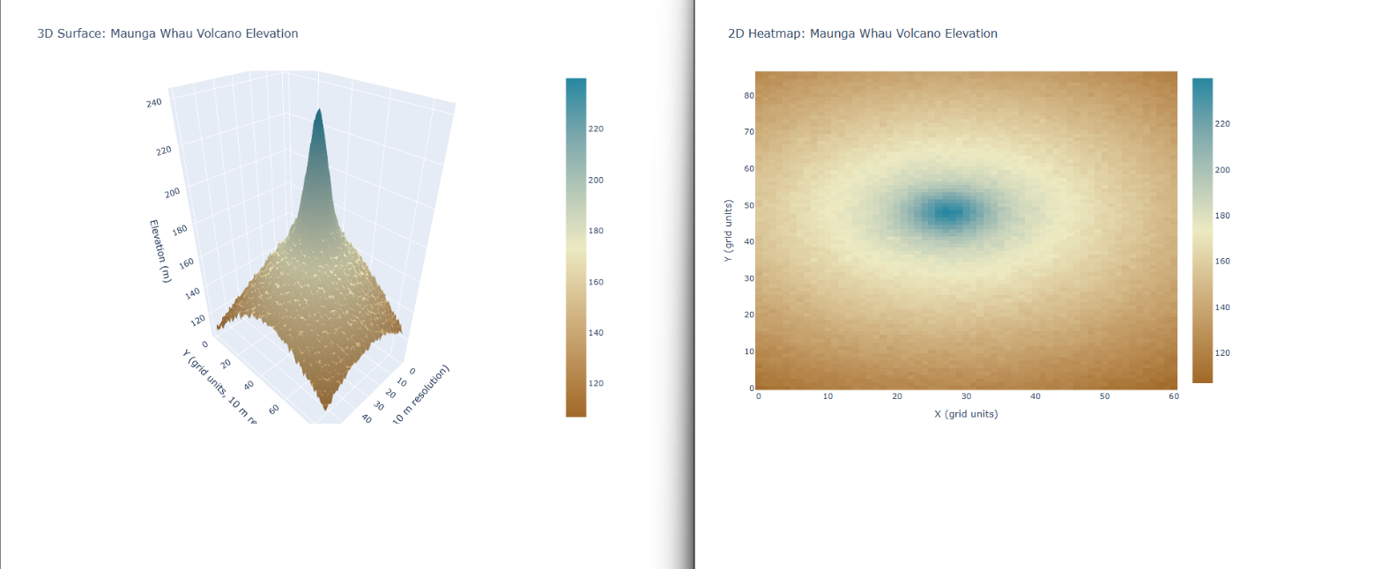
print("\n================ Q5 INTERPRETATION ================")
print(
"The 3D surface view reveals the volcano's actual cone shape, including "
"the steepness of its slopes and the shallow crater dip near the summit, "
"neither of which is visible when looking straight down from above.\n"
"The 2D top-down heatmap, in contrast, shows the concentric rings of "
"elevation more clearly and makes it easier to precisely read off the "
"(x, y) location of the summit and compare elevation contours at a "
"glance, since there is no occlusion or distortion from a 3D viewing angle."
)

